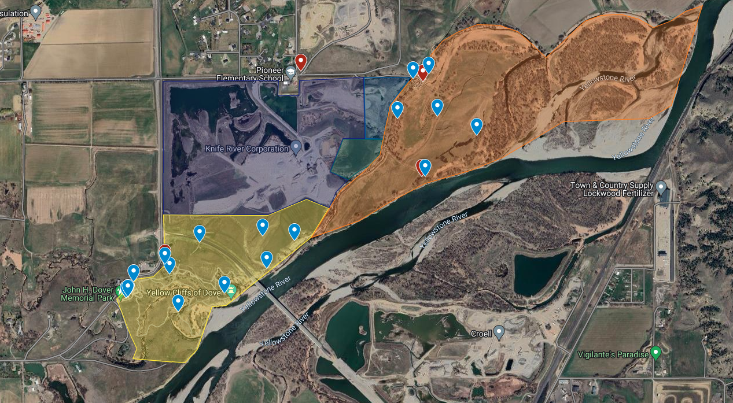

HQ, entrances, bathrooms
Area 2 Headquarters
Bathroom

Area 2 Projects
Box Culvert-Clean dirt and debris out of box culvert

Program Space-Organize / move materials to create more functional storage and program space.

Rock Drill-Clean up glass, hoses, and other loose materials from old rock drill. Intention is to leave in place but make as safe as possible for climbing on

Green Bridge-Sand and re-paint green bridge. Provided by YRPA(Need scuffers /scrapers, paint, brushes, trays, cleaning materials)

Handrail on switchback trail-Increase accessibility by installing handrail on switchback trail between parking area and picnic table.

Buffalo Ridge Trail-Spread fabric and limestone onto trail; include one or two wider spaces for viewing

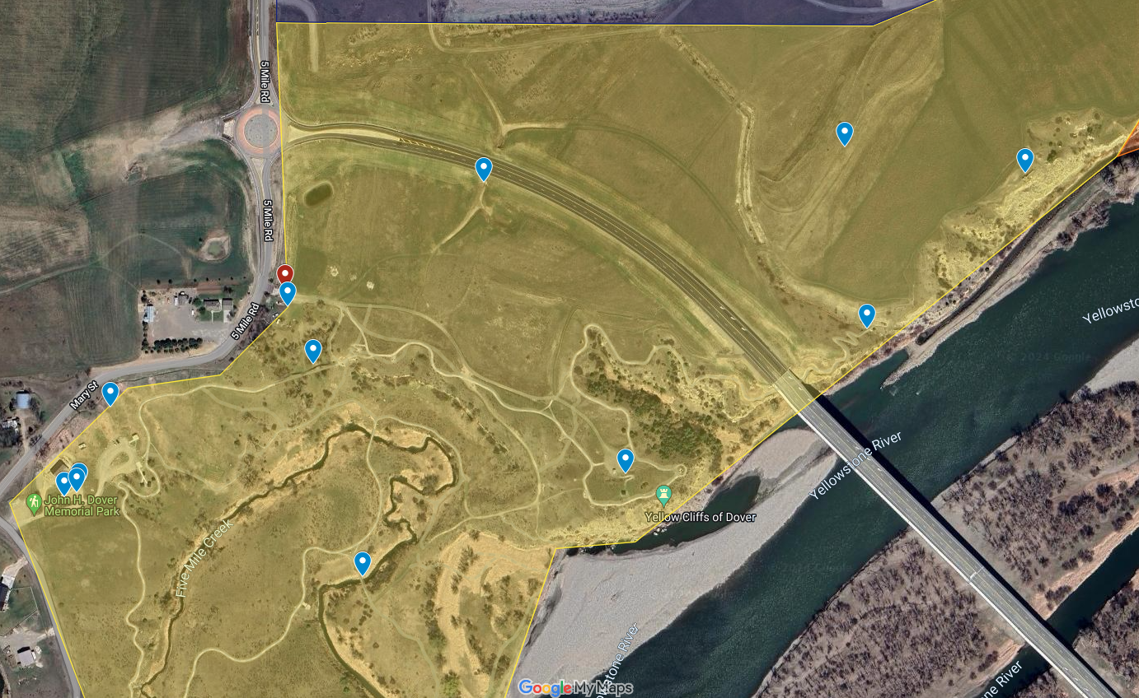
Area 2 Red Zone Headquarters
Area 2 Red Zone
Area 1 Stain Bridge
Program Space
Box Culvert
Buffalo Ridge Trail
Rock Drill
Green Bridge
Handrail on switchback trail
Bathroom
Area 2 entrance
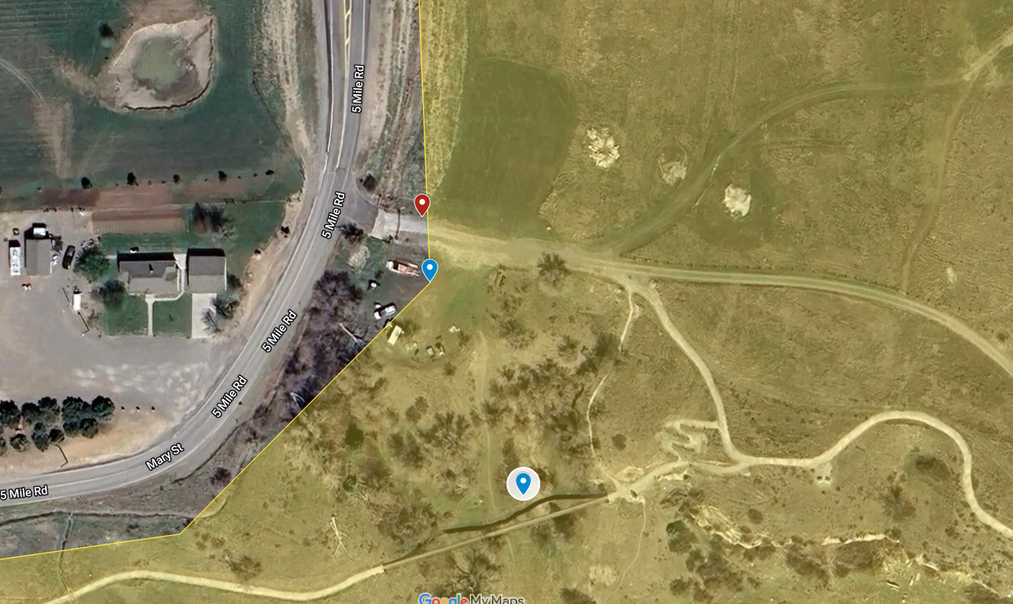
Area 2 Red Zone entrance- 5 parking spots
Gate Keeper
Maintenance Road 1/8 mile from Trailhead/Area 1, before roundabout
5 Parking/bathroom
Area 2 Headquarters
Area 2 entrance

